**Define roles and responsibilities**

Meeting Planning

* What is your team's preferred communication method - email, text, bcourse messaging?
  + Email: we have exchanged each other’s email addresses.
* When will your team be holding meetings? How frequently will you meet? Are there times or days that work well for everyone?
  + Thursday from 2-3pm prior to the assignment submission deadline, over zoom.<https://berkeley.zoom.us/j/6779505955>
* Discuss future non-academic commitments that might affect members' availability.
* Discuss meeting tempo: “checking in” at the beginning of meetings versus “just sticking to business”.
  + Check in + access needs

Roles

* How is your team going to keep track of progress? Who will be taking minutes, creating agendas, and contacting the course facilitators with questions?
  + Ruben will create meeting minutes and create agendas
  + Meredith will attend office hours with questions

<https://phw251avery.setmore.com/>

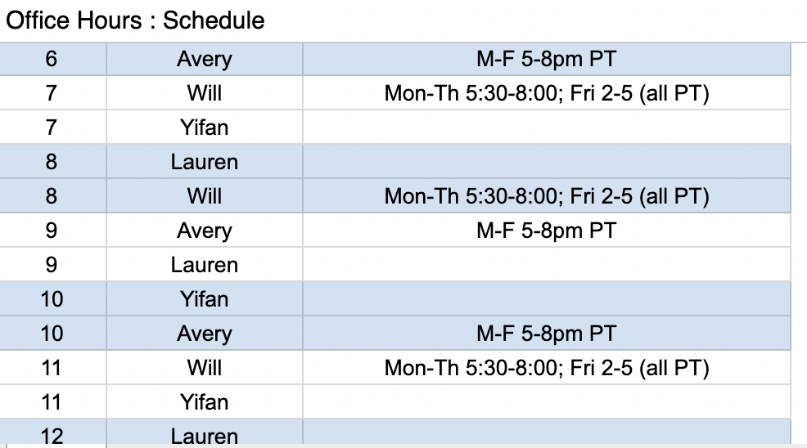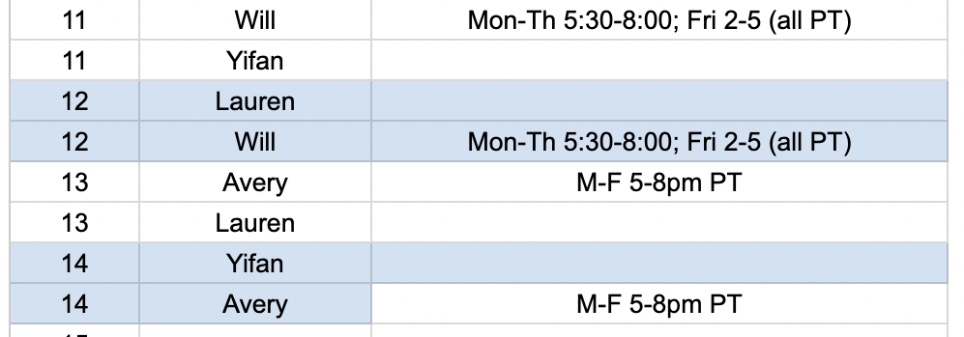

* + Progress will be tracked through check ins
* We encourage you to discuss potential dates and times to meet with a course facilitator during Weeks 3-5. Decide on the best date and time for all.
  + Meet with teaching team on Thursday Sept 30 at 6pm
* Determine a point person to submit each assignment for the team.
  + Meredith can submit

Conflict Management

* If a conflict arises, plan to solve the issue as soon as possible. This is best done using synchronous (Zoom, Google Hangouts) communication rather than asynchronous (email).
* If the group is unable to resolve the conflict, seek advice from the instructional team.

Project Topic:

* **Scenario 1 Hospital Funding and Health Equity**